Computer Network: Lab 2

Name: Rithvik Rajesh Matta

SRN: PES2UG23CS485

Section: H

Problem Statement:

Understanding Persistent and Non-persistent HTTP Connections

Software Tools:

Firefox, Wireshark, Apache Server

Non-Persistent:

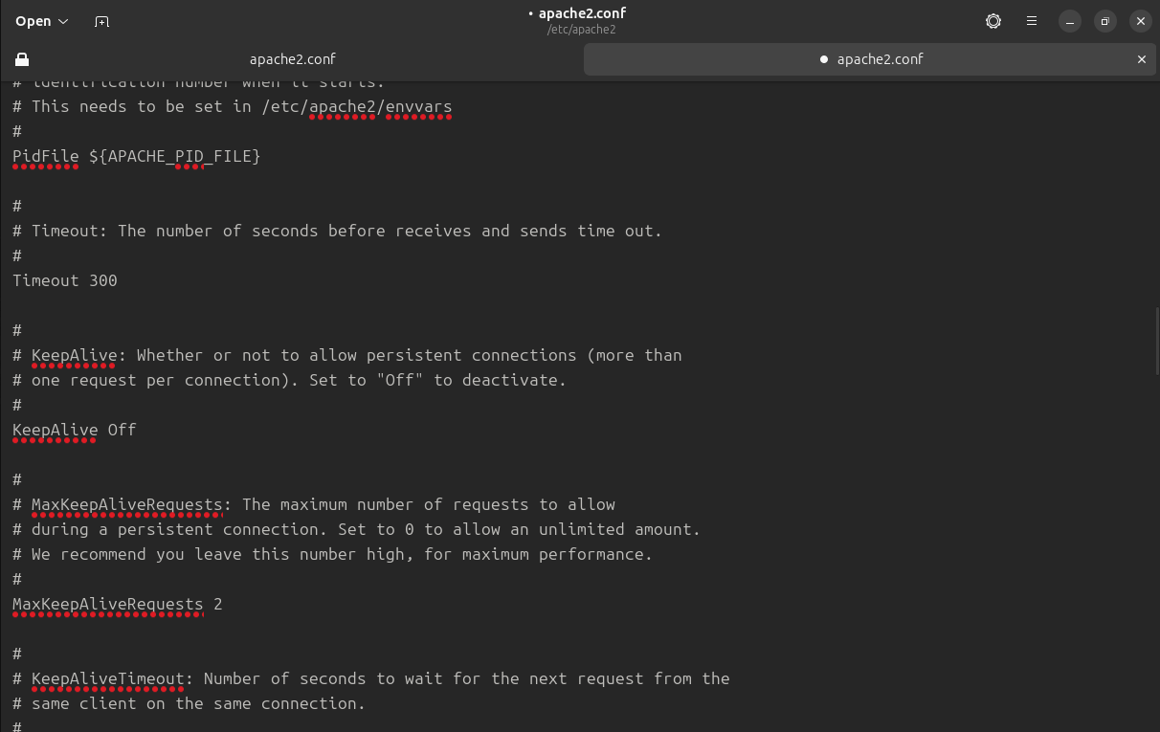

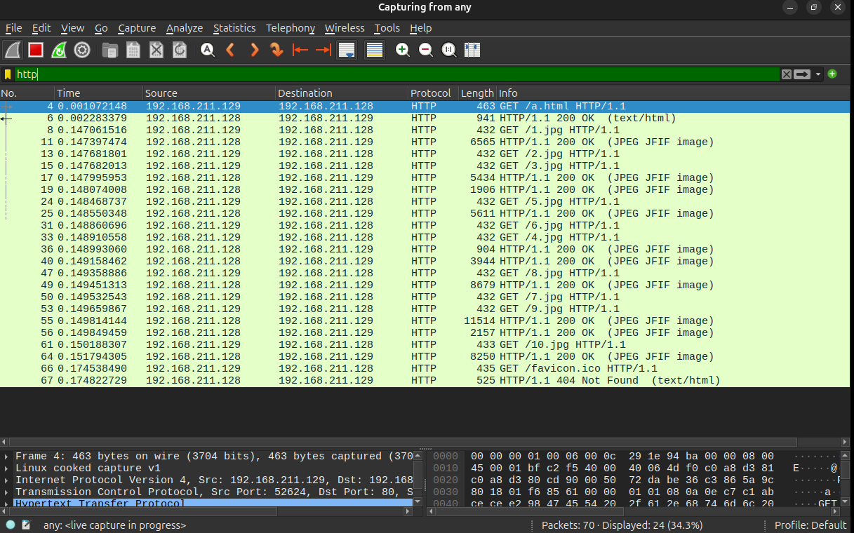Persistent 2: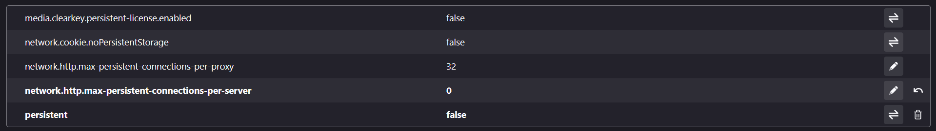

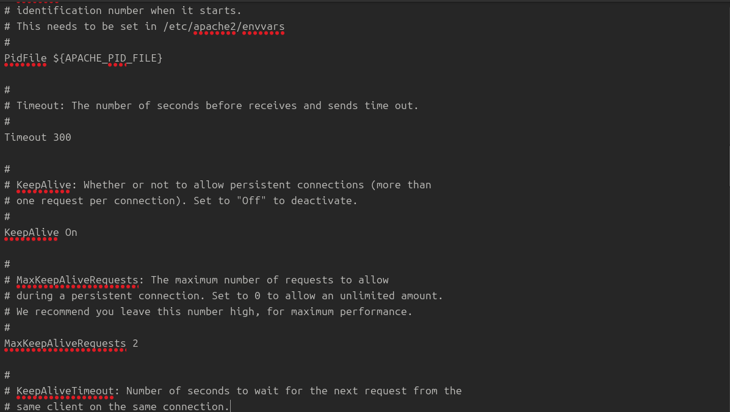

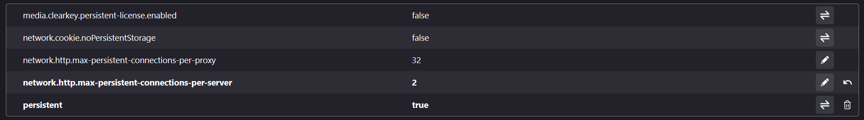

Persistent 4:

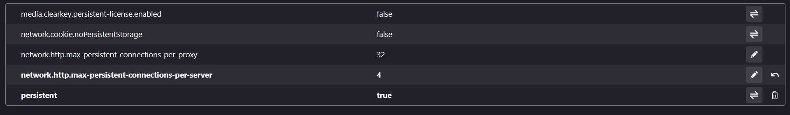

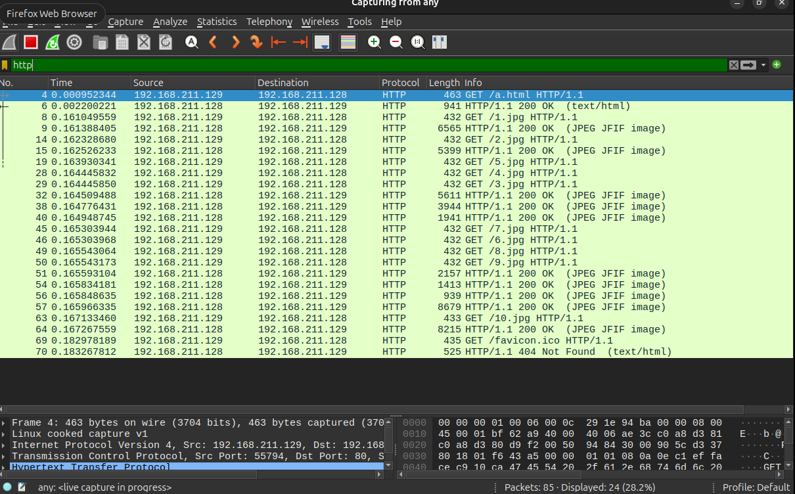

Persistent 6:

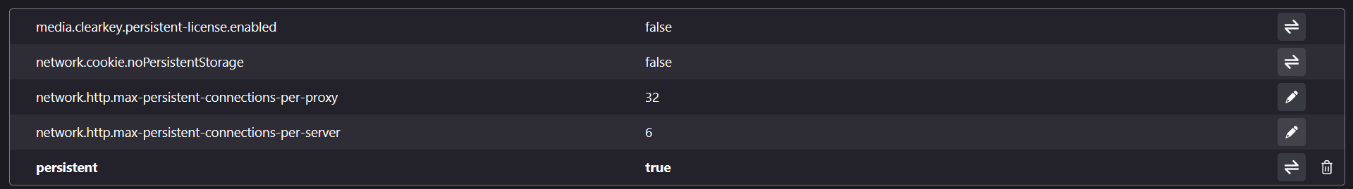

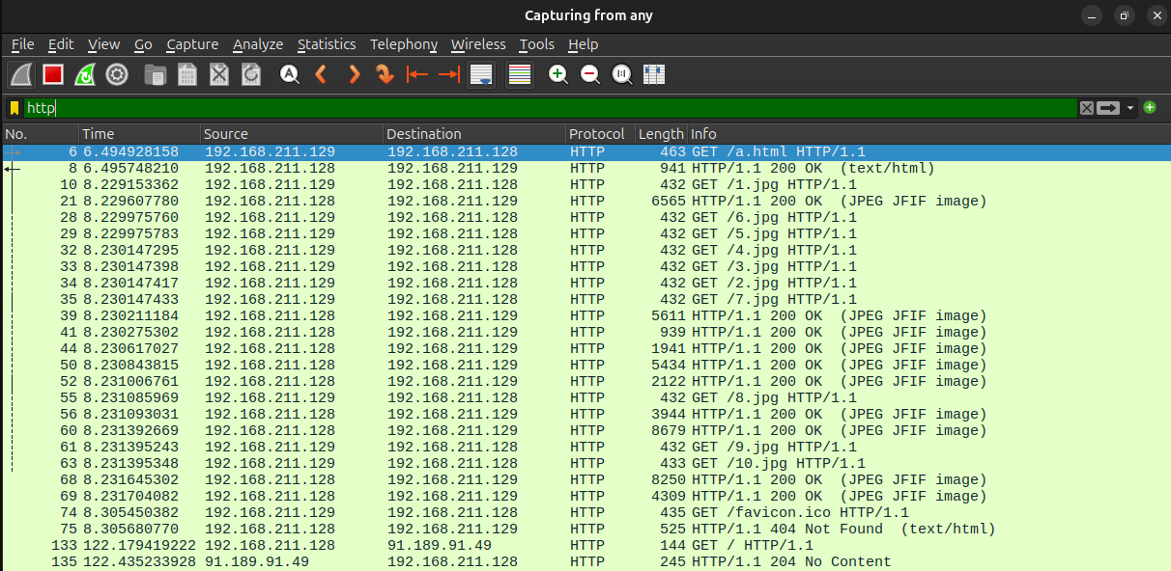

Persistent 8:

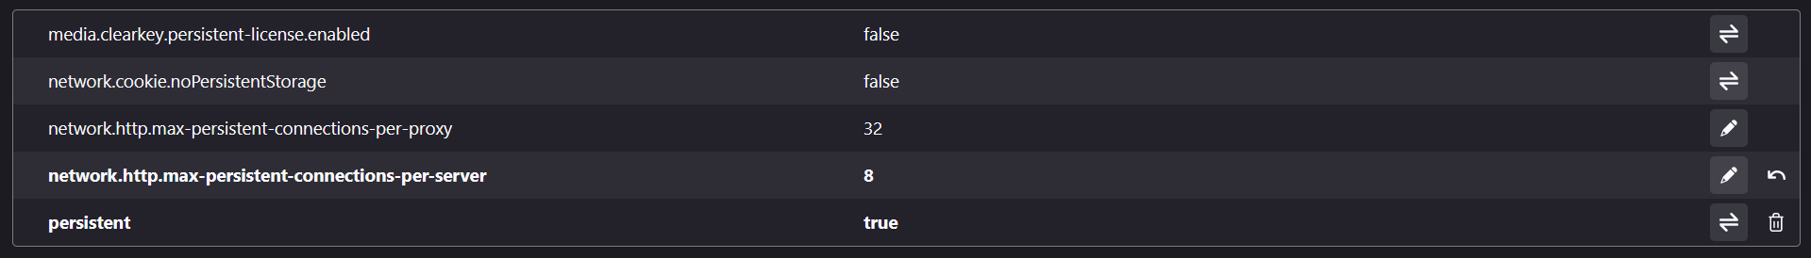

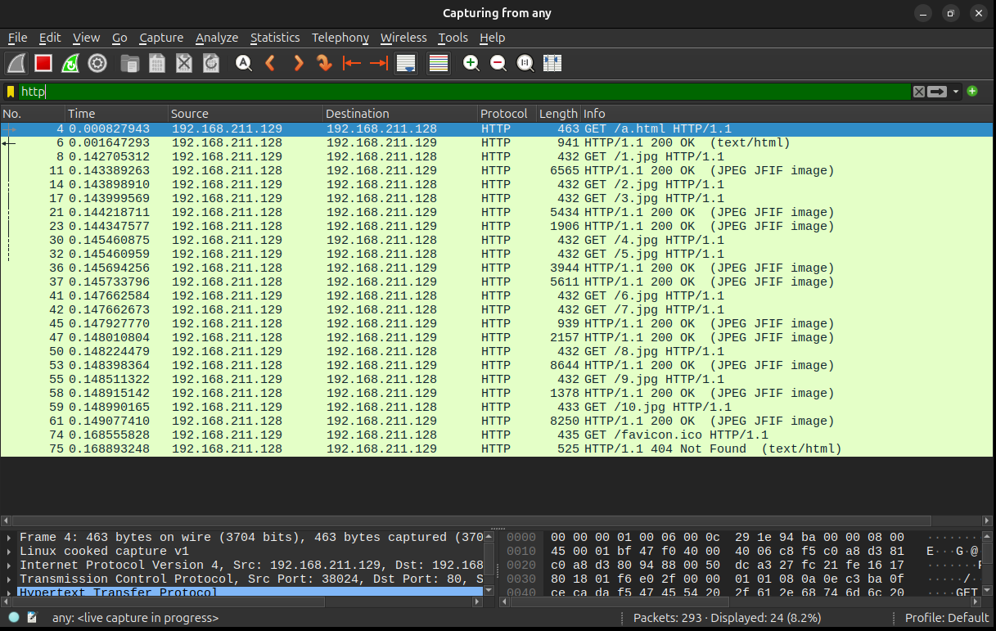

Persistent 10:

